Course Syllabus – week 5

Earth’s Climate: Past, Present and Future
Week 5, October 14th, 2014
Fall Term - OLLI West; Tuesday 9:30-11:30 am
Models, Rates of change, IPCC/AR5
My email contact is (copy/paste) pebelanger@glassdesignresources.com
- Tuesday October 14th, 9:30-11:30 a.m.:
- Future projections and feedbacks:
- Models
- Rates of change: analogs and various comparisons to the past
- IPCC Fifth Assessment report (AR5): http://www.ipcc.ch/report/ar5/

- LAST WEEK – COVERED:
Future projections and feedbacks
Models
- Rates of change: analogs and various comparisons to the past
  - Ocean Acidification – 15 min video (5.5)
  - http://www.skepticalscience.com/ocean-acidification-global-warming.htm
  - NASA Article: http://www.nasa.gov/topics/earth/features/climate_acidocean.html
  - Impacts: Ocean acidification has enormous implications for the functioning of natural systems. However, its human impact cannot be overlooked either. Engage with your peers on the discussion facility to answer these two questions:
- Will marine organisms be able to adapt to ocean acidification given the time scale for the predicted changes?
- Increased carbon dioxide in the atmosphere is likely to lead to sea level rise. Are rising sea levels more of a threat to humanity than ocean acidification?

See http://www.skepticalscience.com/No-alternative-atmospheric-CO2-draw-down.html
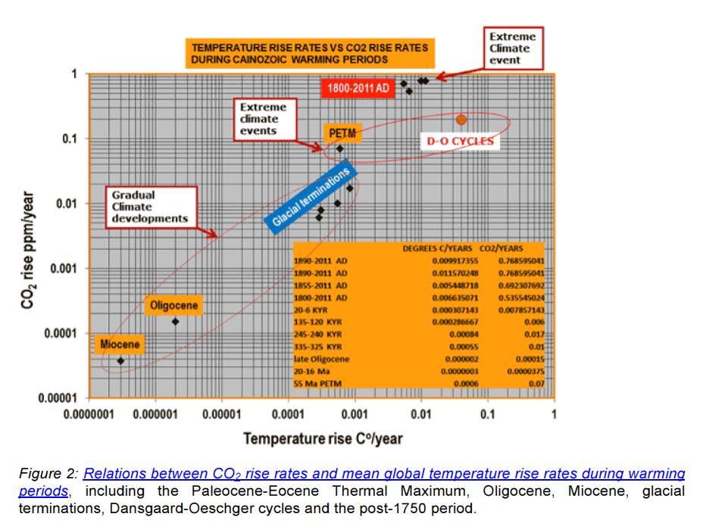
- IPCC Fifth Assessment report (AR5): http://www.ipcc.ch/report/ar5/

PowerPoint Presentation – go to web site for downloading copies
NEXT WEEK:
- Tuesday October 21st, 9:30-11:30 a.m.:
- Solutions?
- Geoengineering: Solar Radiation Management (SRM) and Carbon Dioxide Removal (CDR)
- The economics of doing nothing vs. the economics of mitigation
- There is promise, but at what cost? (One might be surprised).
- Biochar vs. BECCS solutions SEE MY BIOCHAR LINK IN OTHER PAGES: http://denverclimatestudygroup.com/?page_id=28

