Course Syllabus – week 5

Earth’s Climate: Past, Present and Future
Week 6, October 21st, 2014
Fall Term - OLLI West; Tuesday 9:30-11:30 am
Future Promise of Energy and Mitigation:
- Fusion, and
- Geoengineering (SRM, CDR/CCS, Carbon negative technologies)
My email contact is (copy/paste) pebelanger@glassdesignresources.com
- Tuesday October 21st, 9:30-11:30 a.m.:
- Solutions?
- Geoengineering: Solar Radiation Management (SRM) and Carbon Dioxide Removal (CDR)
- The economics of doing nothing vs. the economics of mitigation
- There is promise, but at what cost? (One might be surprised).
- Biochar vs. BECCS solutions SEE MY BIOCHAR LINK IN OTHER PAGES: http://denverclimatestudygroup.com/?page_id=28

- LAST WEEK – COVERED:
- Rates of change: analogs and various comparisons to the past
  - Ocean Acidification – 15 min video (5.5)
- IPCC Fifth Assessment report (AR5): http://www.ipcc.ch/report/ar5/
- Recommendation for looking at HHMI: Naomi Oreskes – How do we know we are not wrong about climate change

But First: Naomi Oreskes – and How do we know we are not wrong (on climate change) HHMI VIDEO:

FUSION – QUOTING Ron Larson in an exchange of emails:

1. The best report available yesterday was:

http://www.lockheedmartin.com/us/products/compact-fusion.html

The 10-person Lockheed team possibly has contained a plasma already – but almost certainly no fusion.

2. There was more today at the Aviation Week site. Next week’s issue will have this as the cover story, with much already at/near these sites:

http://aviationweek.com/blog/high-hopes-can-compact-fusion-unlock-new-power-space-and-air-transport

http://aviationweek.com/fusion-podcast

All positive remarks. Mention of a Nobel prize if they meet their schedule. Personally, I can’t remember any bigger energy supply announcement – ever – if it pans out. Of course it may not. But either way, it should change public thinking about our energy future in major ways for at least the next five years.
3. Summarizing briefly, Lockheed is proposing a 100 MW plant in a space not much larger than a semi. Lockheed says this will allow an aircraft to have unlimited range and time in the air. Supposed to be 10 times better performance than the Tokamak and ITER fusion approaches. Cheap. Safe. All because they are going small. Lockheed is looking for funding based on a goal to operate for 10 minutes in five years, doing five annual updated designs by then. If successful, the next goal will be commercial units available in 10 years. They announced now in order to obtain financial partners. My guess is that won’t be difficult. This particular part of Lockheed has a good science/engineering reputation; I have found no mention of a hoax.

4. This announced schedule will eliminate (if, big if, they are correct) the need for much fossil fuel, so a successful reactor should make it easier to get enthusiasm for all forms of CDR. Their “small” systems can be disseminated widely quickly. Since they are basically producing only thermal energy, biomass/biochar (rather than natural gas) could be the best non-fossil backup option, with some reduction in the need for wind and solar.

The fastest moving biochar operation today (Cool Planet) is supplying a biofuel. A successful Lockheed system would cut into the Cool Planet future market some, but their system could not supply liquid fuels.

If 100 MW is near the smallest possible fusion system, this still leaves plenty of market for smaller combined heat, power and biochar (CHPB) systems.

Land requirements can be much reduced if less biochar is needed. Biochar similarly operates with a small unit scale, which will be favored by many.

AR5; WGIII Mitigation

WGIII_AR5_Presentation or in PDF format

wg3_ar5_summary-for-policymakers_approved

Video – the geoengineering dilemma 4.5 7.3 minutes

Are Ideas to cool the planet realistic
http://news.bbc.co.uk/2/hi/technology/8338853.stm

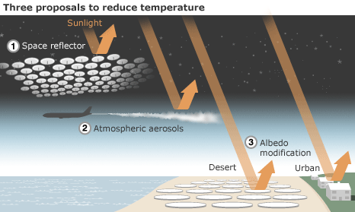
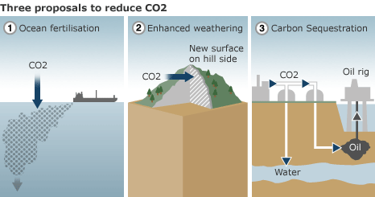
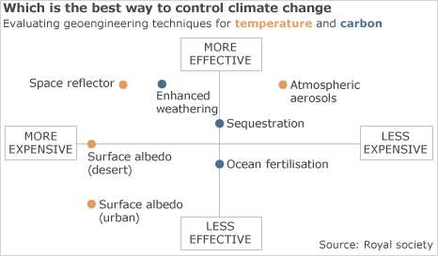

Mitigation and adaptation – 7.1 3.35 minutes
PowerPoint Presentation – go to web site for downloading copies
NEXT WEEK:
- Tuesday, October 28th, 9:30-11:30 a.m.:
- It’s not about climate change as much as sustainability
- Energy
- Urban heat islands
- Food security
- Population growth; potential refugee issue of climate change

