Thursday Colloquium
IiNtetho zoBomi:
Fostering Ethical Living

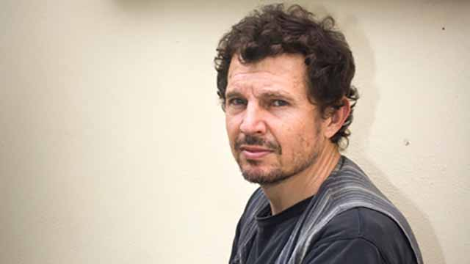

Pedro Tabensky
Allan Gray Centre for Leadership Ethics
Department of Philosophy
Rhodes University
South Africa

4:00 Thursday May 17th
In ‘The Loft’ of the Anderson Academic Commons

IiNtetho zoBomi (‘zoBomi’ hereafter) means “Conversations About Life” in isiXhosa, the language of Nelson Mandela and Desmond Tutu. The programme that carries this name, and about which I will be speaking today, is the brainchild of the Allan Gray Centre for Leadership Ethics (AGCLE) of which I am the Director. It aims to address concerns regarding the current global university and also more narrow concerns with philosophical ethics as practiced today.

The concerns expressed above are consonant with those of philosophers Eric Schwitzgebel and Joshua Rust who use empirical methods to reach the conclusion that moral philosophers are on average no more ethical than Average Joe. And this result is not perplexing to most moral philosophers working in philosophy departments across the globe, for they take their work to be primarily theoretical (understood in the dualist sense). And those philosophers that have practical aims in mind tend to think that we can change people by furnishing them with ethical equipment, that is, with a toolbox that will allow them make better ethical calculations when confronted with complex situations requiring differing levels of conceptual subtlety.

In my talk, I will discuss the ways in which we have addressed the above concerns and created an immensely popular programme that we are rolling out in high schools and at Rhodes University.

