Course Syllabus
Earth’s Climate: Past, Present and Future

Fall Term - OLLI West
September 16– November 4, 2011

Tuesday, September 16th, 9:30-11:30 am

My email contact is (copy/paste) pebelanger@glassdesignresources.com

OLLI WEEK 1, September 16, 2014 page

Welcome to our first class Tuesday September 16th 9:30-11:30
Climate Principles, feedbacks, cycles and climate self-regulation

- Tuesday September 16th, 9:30-11:30 a.m.: Introduction
- Introductions
- web page: http://denverclimatestudygroup.com/
- DU portfolio: http://portfolio.du.edu/earthclimate
- Key principles of climate change
- The difference between weather and climate
- Climate system: feedbacks, cycles and self-regulation (climate, not government)
- What determines Earth’s climate

Intro: my background, web page http://denverclimatestudygroup.com/ (OLLI tab) and DU portfolio, CV (about tab)
Logistics
Stan Hamilton: classroom assistant, liaison to me/OLLI

Reflective learning: notes, write a blog, etc. I might use a WordPress blogger, or comment on the home tab, box OLLI, or DU’s Portfolio http://portfolio.du.edu/earthclimate which I’m still figuring out :
- Insights,
- examples,
- case studies,
- comments/ other

Credits/acknowledgements helping me organize my thoughts/syllabus go to the MOOC course I took January/February 2014 from the University of Exeter:
As well as and HHMI (http://www.hhmi.org/) especially their streaming video holiday series (4 hours) in 2012-13 that can be found at http://www.hhmi.org/biointeractive/changing-planet-past-present-future

Key Principles
- Greenhouse metaphor effect: essential for keeping Earth moderate day/night
  - Visible vs. Infrared/longer wave – a function of “black body” temperature: instead of glass keeping the heat in it’s the gas properties keeping the heat of infrared in; blanket effect.
- Greenhouse gases (GHGs) and feedback:
  - Water – H2O – the amount is a feedback of temperature held in by the “blanket” of other GHGs
  - Carbon dioxide - CO2
  - Methane - CH4
  - Ozone - O3
  - Nitrous oxide- N2O
  - others
Blanket Earth:
http://climate.nasa.gov/causes/

What is climate?

https://www.futurelearn.com/courses/climate-change-challenges-and-solutions/steps/563/progress go to 1.4
You tube link: https://www.youtube.com/watch?v=bjwmrg__ZVw

This video, produced by the UK Met Office, is an excellent introduction to understanding the climate system and, in particular, the key differences between weather and climate.
See: http://www.metoffice.gov.uk/climate-guide

The difference between weather and climate
Weather: temp, rain, wind; hour by hour and day by day
Climate: 30 year average
Climate zones:
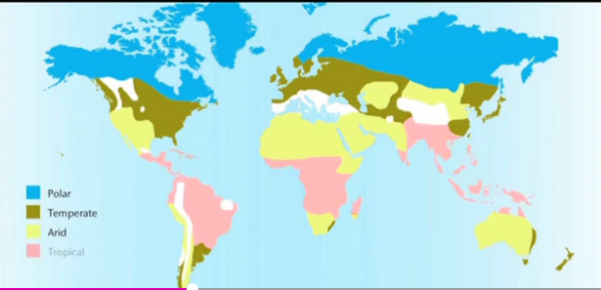

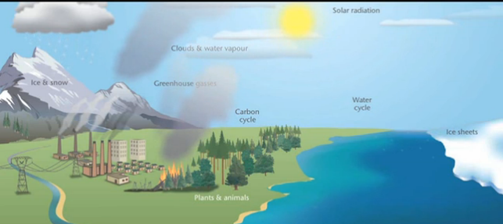
a climate system

role of the atmosphere:
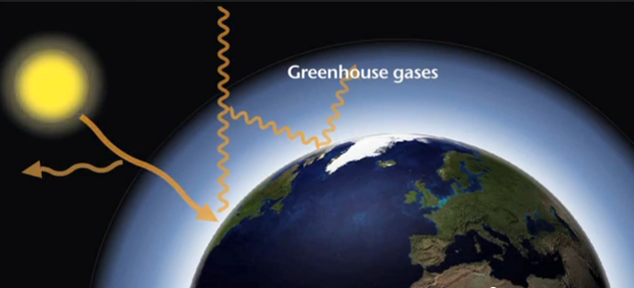

Climate change: the statistics of weather change

Discussion:
What’s the difference between weather and climate?

The climate system, feedbacks, cycles and self-regulation
https://www.futurelearn.com/courses/climate-change-challenges-and-solutions/steps/3294/progress (7 mins)
an alternate: https://www.youtube.com/watch?v=lrPS2HiYVp8
5 key elements and their interrelationships:

- Atmosphere
- Hydrosphere
- Biosphere
- Cryosphere
- Lithosphere
The sun is key to linking all these through water.
Feedbacks: positive and negative
- Water vapor
- Ice albedo
- Radiation feedback

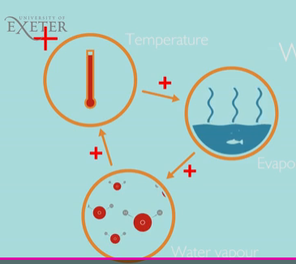

Long term regulators of climate:
Positive feedbacks in a mathematical sense:
- Water feedback: increase temp >>> ++ evaporation >>>++water vapor
- Ice Albedo feedback: --- sea ice/high albedo >>> ---reflection >>>> warming >>>--sea ice
- Radiation feedback: the warmer a body is the greater the radiation it gives off – i.e. it cools it down.
http://en.wikipedia.org/wiki/Stefan%E2%80%93Boltzmann_law

What factors determine Earth’s climate:
See IPCC-AR5 (2013-2014) tab on my web page:
And this link from AR4 (2007) http://denverclimatestudygroup.com/?page_id=63
http://www.ipcc.ch/publications_and_data/ar4/wg1/en/faq-1-1.html
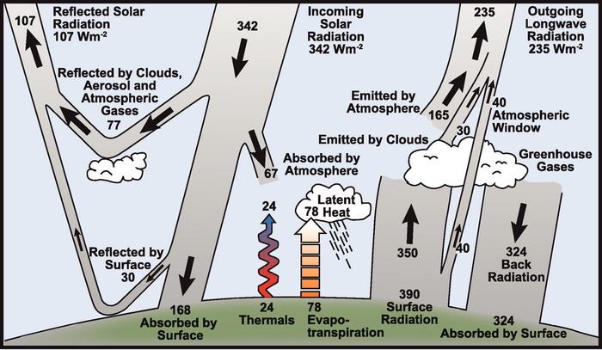

Questions:
- Which of the following are GHGs:
- Water vapor
- CO2
- CH4
- O2
- Ar
- O3
- N2O

- Which is correct:
  - Greenhouses keep warm by reducing heat loss from convection
  - Greenhouses gases limit loss by reducing convection
  - Greenhouses gases trap long wave radiation in the atmosphere

- How much solar radiation does the Earth reflect (albedo) ? How about ice/snow?
  - 70
  - 30
  - 10
  - 95

- Which has the highest albedo?
  - Desert sand
  - Tropical forest
  - Ice/snow
  - Ocean

- What does IPCC mean? What does AR# mean?
Intergovernmental or International? What?

Reflect on these key questions:
- What the key scientific principles that explain climate change including the greenhouse (blanket) effect?
- What are the key feedback mechanisms that help to explain why our climate is able to “self-regulate”?
- How can our climate be conceptualised as a system containing a series of components that interact with one another?
Also consider:
- What are the most important themes you have learned this week?
- What aspect of this week did you find difficult?
- What did you find most interesting? And why?
- Was there something that you learned this week that prompted you to do your own research?

