Course Syllabus – week 4

Earth’s Climate: Past, Present and Future
Week 4, October 7th, 2014
Fall Term - OLLI West; Tuesday 9:30-11:30 am
Signs of Climate change
My email contact is (copy/paste) pebelanger@glassdesignresources.com

- Tuesday October 7th, 9:30-11:30 a.m.:
- Follow up to ice core lab field trip: Overview of slides week 3 never covered with need to move on.
- Signs of climate change/how has it changed: ocean acidification, Arctic warming
  - http://www.uh.edu/~jbutler/kunming/carbonates.html
  - CaCO₃ + H₂CO₃ = Ca⁺² + 2HCO⁻₃ [1]
  - H₂CO₃ is carbonic acid - a relatively weak naturally occuring acid that forms by the reaction between water and carbon dioxide: H₂O + CO₂ = H₂CO₃ [2]

- Global carbon emissions of Carbon dioxide (CO₂) and Methane (CH₄)
  - See slides of last week/this week – I’ll point them out
- We are changing climate:
  - Weather indicators – video
  - http://www.goes-r.gov/
  - Climate indicators http://www.metoffice.gov.uk/research/monitoring/climate
  - extreme events and anomalies http://www.climate.gov/news-features/featured-images/state-climate-extreme-events
- your warming world – a model .

  - What has been happening where you live (see link below)? Follow the link below the interactive map to look at the global annual mean temperature changes. Click on the country where you live to see the summary climatology plot. The plot shows temperature or precipitation changes. The black line shows observations from 1980-2004, the blue line is the model control simulation and should closely follow the black line and the red line is the future projection for 2050-2074 for the country you have selected. The vertical lines on the plot show the standard deviations for each month and indicate the variability. http://regclim.coas.oregonstate.edu/visualization/gccv/cmip5-global-climate-change-viewer/index.html
  - You can read how the map was produced by following this http://regclim.coas.oregonstate.edu/visualization/gccv/gccv-tutorial/index.html
- Urgent action: What would you consider the largest threats from extreme weather events to where you live?
The American Geophysical Union (AGU) is a union of scientists dedicated to enhance the understanding of geophysical science.
Follow this (http://sciencepolicy.agu.org/files/2013/07/AGU-Climate-Change-Position-Statement_August-2013.pdf ) to the latest statement on climate change which was released in August 2013 and is titled Human-induced Climate Change Requires Urgent Action. The statement refers to some of the observations introduced in this week’s lesson including increases in air temperatures, sea level and reductions in Arctic sea-ice. What other examples are included in the statement?
The statement also includes climate projections, which we will introduce next week. Having read the statement what would you consider the largest threats to where you live?
- Our changing carbon cycle: video 3.6 - 4 minutes
  - Professor Pierre Friedlingstein identifies the components of the carbon cycle and how human activity has contributed to an atmospheric concentration of carbon dioxide not seen since the Pliocene epoch between 2.6 and 5.3 million years ago.
  - 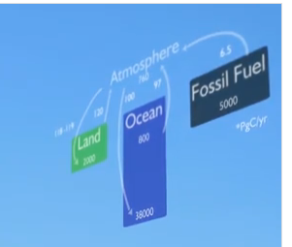and 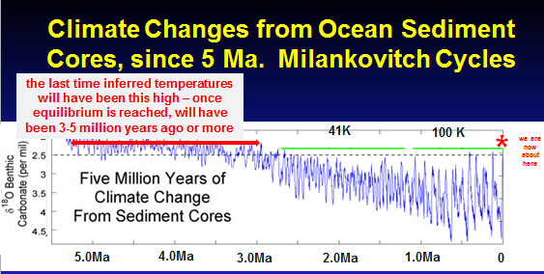

Global carbon emissions (optional) http://data.worldbank.org/indicator/EN.ATM.CO2E.KT/countries/CN-GB-US?display=graph
The World Bank publishes a variety of environmental data, including carbon emissions (measured in kt). Create a graph to show a variety of countries at different levels of economic development by following the link above to the World Bank web site. Include the USA and China in your graph. Share your graph in the discussion. You may also want to try plot carbon dioxide emissions measured in metric tons per capita. What conclusions can you draw?

Future Projections:

Modeling video: Making future projections and modelling future scenarios 4.1 video/7mins; I want to show this now because you won’t be able to see it offline except other unvetted google searches.
https://www.futurelearn.com/courses/climate-change-challenges-and-solutions/steps/3296/progress
In the video Professor Peter Cox introduced the future scenarios in relation to economic and technological development. What role will these play in how much more our planet will warm?

How Much More Will Earth Warm?
http://earthobservatory.nasa.gov/Features/GlobalWarming/page5.php
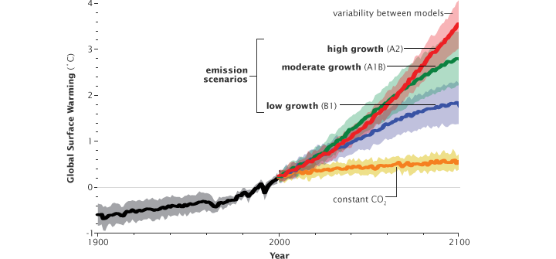
**************************
Run your own Model? (optional): http://www.climateprediction.net/
If interested email me pebelanger@glassdesignresources.com and I’ll send more info and files you will need.
**************************

IPCC Fifth Assessment Report
See my web page:
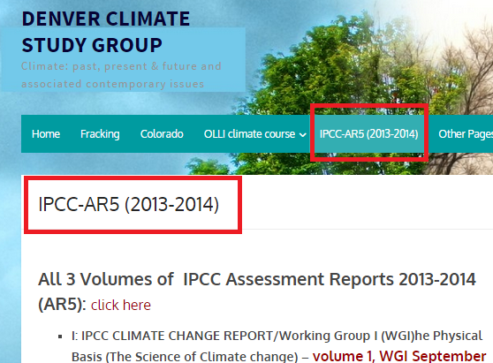
I’ll talk about these links and a PPT I presented a few weeks ago.

