Week 7 expanded syllabus:
Earth’s Climate: Past, Present and Future
Week 7, October 28th, 2014
Fall Term - OLLI West; Tuesday 9:30-11:30 am
Future Promise Part B:
- Biochar
- Adaptation issues: sustainability
- Nimby
My email contact is (copy/paste) pebelanger@glassdesignresources.com
- Original syllabus for Tuesday, October 28th, 9:30-11:30 a.m.:
- It’s not about climate change as much as sustainability
- Energy
- Urban heat islands
- Food security
- Population growth; potential refugee issue of climate change

Revised and expanded syllabus:
Biochar, promise for the future?

BIOCHAR – 2012 VIDEO STARTS EARLIER WITH: Video link for start - https://www.youtube.com/watch?v=JPJsYZLU_sM&list=PLgCXzlciS1W3V4E6RZ0ePAXCWFLOH5kC7
- Morgan Williams, CEO Biochar solutions (not shown in class)

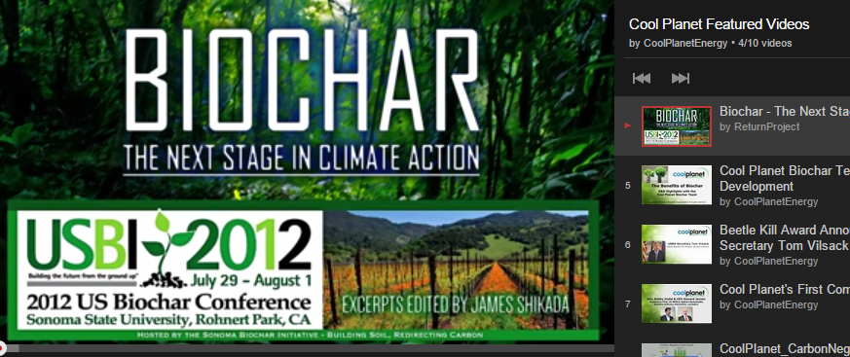
0 to 3:57
Morgan Williams – president/ceo Biochar solutions
1 km trees = 1 million tons CO2
Human output 8 gigatons carbon = 32 gigatons CO2 or 32,000 times those trees
Efficiency doesn’t remove carbon
Carbon negativity – $25million prize for gigaton sequestering 3200 piles of wood
- Air capture
- Biochar 3 companies
- Beccs – biomass powerplant and CCS
- Enhanced wx
- Land mgt – Savory institute

- and at 3:57 – David Laird, Iowa state u/dept Agronomy (not shown in class)
Geologist background, soil and earth science background
Oil coal and natural gas 7million workers and 1.9 trillion dollars in govt subsidies
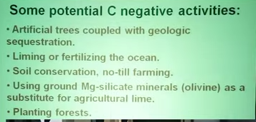
6:00 CCS a drag on economy – not generating economic value.
Soil and water quality improvement
Increased yield;increased value of land for 100s of years
Horticultural, reclamation – soil-water-holding capacity.

- and at 8:55 Cool Planet presentation starts
  - web site: http://www.coolplanet.com/
  - YouTube:
https://www.youtube.com/watch?v=JPJsYZLU_sM&list=PLgCXzlciS1W3V4E6RZ0ePAXCWFLOH5kC7

Mike Cheiky, founder of Cool Planet, admittedly overstates the global climate change fears; please try look and understand the biofuel/biochar technology.
@16:30 claims making gasoline at $1.50/gallon; jet fuel $2.00/gallon:

C3/C4 PLANTS
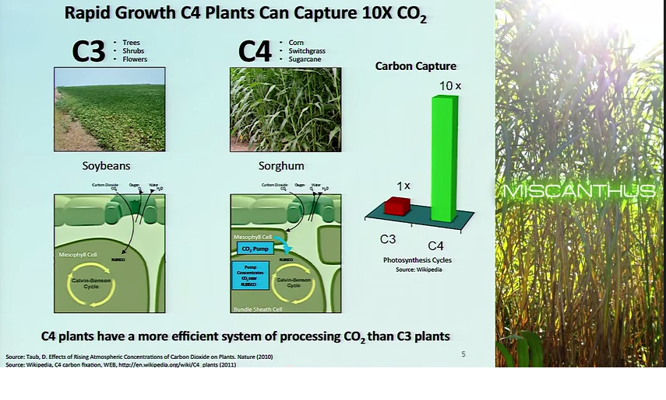
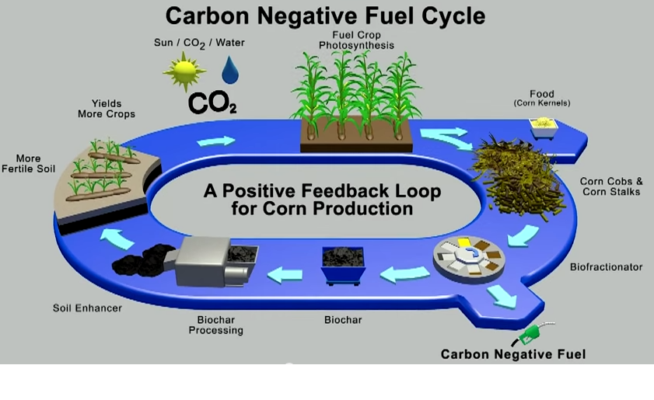
@18:55
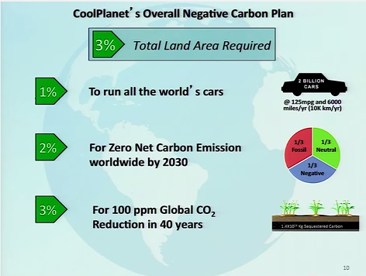
Cool planet presentation ends at 20:40

This continues: and more – please investigate on your own.
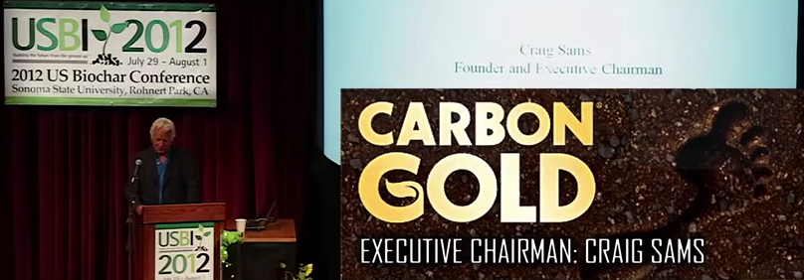
*************************
Adaptation issues: sustainability

Other class coverage: related to AR5/WGII:

II: IPCC CLIMATE CHANGE REPORT/Working Group II (WGII): Impacts, Adaptation and Vulnerability – volume 2, April 2014; especially see:
  - Summary for Policymakers (SPM)
  - Video
  - Presentation
If I’m not able to cover all listed, please google and search out these topics

- Human health and the built environment (6.1; 6.41”) MOOC 6.1 video
https://www.futurelearn.com/courses/climate-change-challenges-and-solutions/steps/2630/progress
Climate change has the potential to change the way we live. How will climate change affect human activity in our built environment? Dr. Tristan Kershaw looks at how climate change can impact on our familiar urban landscapes. How might the severity of urban heat islands increase to constitute a significant threat to human health during heat wave events?
- Urban Heat Islands (6.2):
This web page provides an excellent summary of urban heat islands. How do you think the land use planning in urban heat islands could be used to reduce the scale of such islands? http://earthobservatory.nasa.gov/IOTD/view.php?id=36227
- Video activity (6.3; 7.24”): Climate change and food security
https://www.futurelearn.com/courses/climate-change-challenges-and-solutions/steps/3307/progress
This activity is designed to help you recognize the human impact of climate change on the security of the global food supply. Professor Sarah Gurr introduces a surprising twist to potential impacts of climate change. Is the biggest potential threat to humanity a tiny fungus?

The global food security program (6.4)
The Global Food Security program is a multi-agency program bringing together the interests of the research councils, executive agencies and government departments. Its website is an excellent resource for gaining a broad understanding of this issue.
http://www.foodsecurity.ac.uk/index.html

Tackling food security – thoughts to ponder (6.5)
With a growing population and improving diets there is a need to double our food supply by 2050. Identify three measures you would take meet this demand. Identify one of your measures from your list and post your solution into the discussion - be prepared to defend your choice!

7.1 Mitigation and adaptation – shown last week
Dr. Tristan Kershaw looks at the two key approaches to tackling increasing greenhouse gas emissions – mitigation and adaptation.

7.2 Adapting the built environment
In Dr. Kershaw’s video he visited the Montgomery Primary School, a school built with features that adapt to a warmer climate as well as mitigating against global warming. Browse the document “Design for future climate” published by the Technology Strategy Board to discover how buildings might need to adapt to the uncertainties of climate change. Follow this link to the document (51mb)
Design for future climate - pdf
https://www.innovateuk.org/documents/1524978/1814018/Design+for+future+climate+-+opportunities+for+adaptation+in+the+built+environment/65aeb874-12f2-46aa-a887-14e6f980c006

Nimby
VIDEO ON NIMBY: by Dr. Patrick Devine-Wright showed in class: no public videos but several articles by him – google him and see what you find. The little I found:
Beyond NIMBYism: towards an integrated framework for understanding public perceptions of wind energy http://onlinelibrary.wiley.com/doi/10.1002/we.124/abstract

Abstract
It is widely recognised that public acceptability often poses a barrier towards renewable energy development. This article reviews existing research on public perceptions of wind energy, where opposition is typically characterized by the NIMBY (not in my back yard) concept. The objectives of the article are to provide a critical assessment of past research and an integrated, multidimensional framework to guide future work. Six distinct strands of research are identified, summarized and critiqued: public support for switching from conventional energy sources to wind energy; aspects of turbines associated with negative perceptions; the impact of physical proximity to turbines; acceptance over time of wind farms; NIMBYism as an explanation for negative perceptions; and, finally, the impact of local involvement on perceptions. Research across these strands is characterized by opinion poll studies of general beliefs and case studies of perceptions of specific developments. In both cases, research is fragmented and has failed to adequately explain, rather than merely describe, perceptual processes. The article argues for more theoretically informed empirical research, grounded in social science concepts and methods. A multidimensional framework is proposed that goes beyond the NIMBY label and integrates previous findings with social and environmental psychological theory. Copyright © 2004 John Wiley & Sons, Ltd.
*********
Rethinking NIMBYism: The role of place attachment and place identity in explaining place-protective action: http://onlinelibrary.wiley.com/doi/10.1002/casp.1004/abstract

Abstract
The ‘NIMBY’ (Not In My Back Yard) concept is commonly used to explain public opposition to new developments near homes and communities, particularly arising from energy technologies such as wind farms or electricity pylons. Despite its common use, the concept has been extensively critiqued by social scientists as a useful concept for research and practice. Given European policy goals to increase sustainable energy supply by 2020, deepening understanding of local opposition is of both conceptual and practical importance. This paper reviews NIMBY literature and proposes an alternative framework to explain local opposition, drawing upon social and environmental psychological theory on place. Local opposition is conceived as a form of place-protective action, which arises when new developments disrupt pre-existing emotional attachments and threaten place-related identity processes. Adopting a social constructivist perspective and drawing on social representation theory, a framework of place change is proposed encompassing stages of becoming aware, interpreting, evaluating, coping and acting, with each stage conceived at multiple levels of analysis, from intrapersonal to socio-cultural. Directions for future research and potential implications of the place-based approach for public engagement by energy policy-makers and practitioners are discussed. Copyright © 2009 John Wiley & Sons, Ltd.
*********

Community Benefits Protocol
Community benefits schemes are a well established, integral part of onshore wind energy development, and represent a positive relationship between developers and communities.
As an industry, we are committed to ensuring these benefits are realised within local communities that host wind farms.
- See more at: http://www.renewableuk.com/en/renewable-energy/communities-and-energy/community-benefits-protocol/index.cfm#sthash.4RI2LmD5.dpuf
for more go to http://www.renewableuk.com/en/renewable-energy/communities-and-energy/community-benefits-protocol/index.cfm

Not in my back yard!
In this activity it’s time to reflect on a very different perspective on climate change. Professor Patrick Devine-Wright challenges the view that “decarbonising” the energy grid is a simple, value-free solution to tackling carbon change.

7.4

NOT IN MY BACK YARD! 7.4 8:23” long

7.5Community benefits packages
Professor Devine Wright identifies “community benefits packages” as a key method used by energy companies to help them implement new energy installations.
Follow this link to the Renewable Energy UK website to see this policy in action.
http://www.renewableuk.com/en/renewable-energy/communities-and-energy/community-benefits-protocol/index.cfm

NIMBYs in action
Search for a local campaign group in action near you. What are the main arguments of the local campaign group you have discovered? Share a link to their website in the discussion.

PowerPoint Presentation – go to web site for downloading copies
NEXT WEEK:
Tuesday November 4th, 9:30-11:30 a.m.: conclusion
- Welcome to the Anthropocene
- Looking ahead
- Your carbon footprint
- Is the future of our climate still in our hands?
- Wrap-up

**************************

Added material:

REFERENCES / LINKS:

http://www.worldwatch.org/

Biochar video notes times/links: go to my Biochar page – click here:

From Stan Hamilton/Thanks
- Concerns about the effect of Renewable costs on Germany’s economy: Germany’s Expensive Gamble

NEW MOOC CLIMATE COURSE – 5 weeks:

New MOOC course that starts November 10th, 2014 for 5 weeks:https://www.futurelearn.com/courses/our-changing-climate; Different length and University. Same middlemen as the MOOC course I took from University of Exeter in February 2014 whose syllabus was a model and some of whose videos I showed in class.

Other MOOC courses OF ALL KINDS OF TOPICS – go here: https://www.futurelearn.com/courses/categories

Biochar video notes times/links

New MOOC course that starts November 10th, 2014: https://www.futurelearn.com/courses/our-changing-climate
Different length and University. Same middlemen as the MOOC course I took from University of Exeter in February 2014

