Week 8 expanded syllabus:
Earth’s Climate: Past, Present and Future
Week 8, November 4th, 2014
Fall Term - OLLI West; Tuesday 9:30-11:30 am

Welcome to the Anthropocene
My email contact is (copy/paste) pebelanger@glassdesignresources.com

- Tuesday November 4th, 9:30-11:30 a.m.: conclusion
- Welcome to the Anthropocene
- Looking ahead
- Your carbon footprint
- Is the future of our climate still in our hands?
- Wrap-up

***********************************
BUT FIRST: RELEASED 11/1/2014:

IV: IPCC SYNTHESIS REPORT – 11/2/2014:

Summary for Policy makers: CLICK HERE

Longer report: CLICK HERE

SLIDES: 2 Mb-PDF – CLICK HERE; FOR PowerPoint 48Mb – click here)
Economist 11/2/2014 – thanks Stan – see web page

Welcome to the Anthropocene
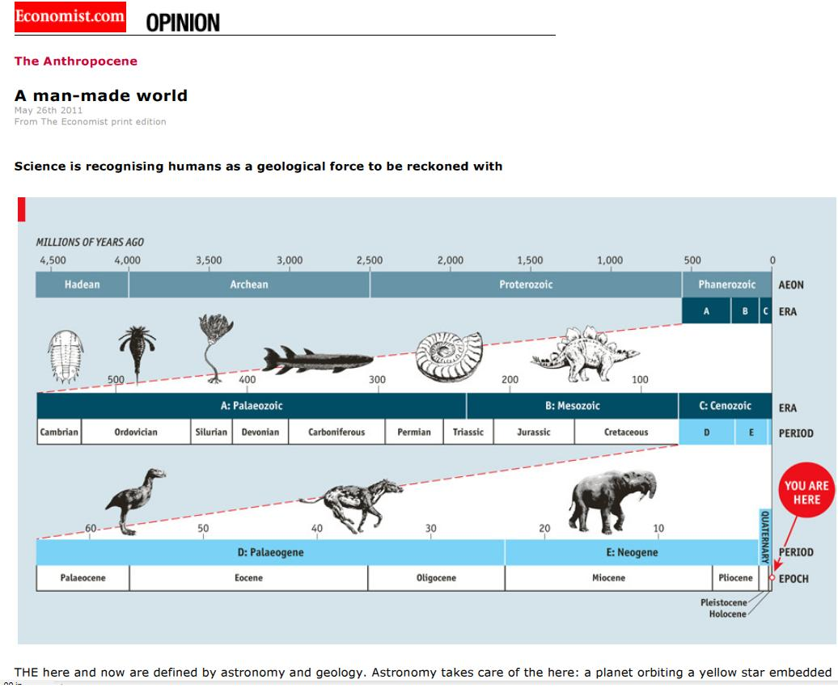
Economist Article May 26, 2011 – see web page:
The human race stands at the dawn of a new epoch of Earth’s history. An epoch which could see changes in the Earth’s climate that will change the face of our planet. Welcome to the Anthropocene. MOOC U. Exeter video 3’31”
http://www.bgs.ac.uk/anthropocene/

Article: The Anthropocene
The word has entered the scientific and popular literature as a vivid expression of the degree of environmental change on planet Earth caused by humans.
Humans are now drivers of environmental change on a scale that is unique in Earth’s history.
Human driven biological, chemical and physical changes to the Earth’s system are so great, rapid and distinct that they may characterise an entirely new epoch – The Anthropocene.
http://www.bgs.ac.uk/anthropocene/

How might it affect you?
One feature of the changing climate of the Anthropocene is likely to be a rise in sea levels. How might sea level rise affect you? Consider environmental, social and economic impacts.

The future of the climate is still in our hands, New Scientist October 4, 2013

Action – video 6’14” (U. Exeter 8.4); think global, act local and remember Biochar

Your carbon footprint
What is meant by your carbon footprint?
The Energy Saving Trust has a useful website that defines what is meant by a carbon foot print as well as looking at what measures might be taken to reduce them. http://www.energysavingtrust.org.uk/
CALCULATE YOUR CARBON FOOTPRINT: http://carboncalculator.direct.gov.uk/index.html

Is the future of our climate still in our hands?

New Scientist: Sea level rise: Drowning in numbers

THANKS ALL!
NEXT WEEK – OK, I ENCOURAGE YOU – it’s free:

NEW MOOC CLIMATE COURSE – 5 weeks:

New MOOC course that starts November 10th, 2014 for 5 weeks:https://www.futurelearn.com/courses/our-changing-climate; Different length and University. Same middlemen as the MOOC course I took from University of Exeter in February 2014 whose syllabus was a model and some of whose videos I showed in class.

Other MOOC courses OF ALL KINDS OF TOPICS – go here: https://www.futurelearn.com/courses/categories

